**Smart scheduling feature Documentation**

**Purpose**

To provide an easy way to interact with the events created onto the calendar.

**Background**

In the platform there exists a calendar with which you can create new events. They can be set site, course or user wide (a matter of scope).

**Usage**

User set events can be moved to different dates by clicking and holding the event and moving it to a desired date. If you wish to move it to the next month, you can hover over the next month and you’ll be moved into that month to insert that date

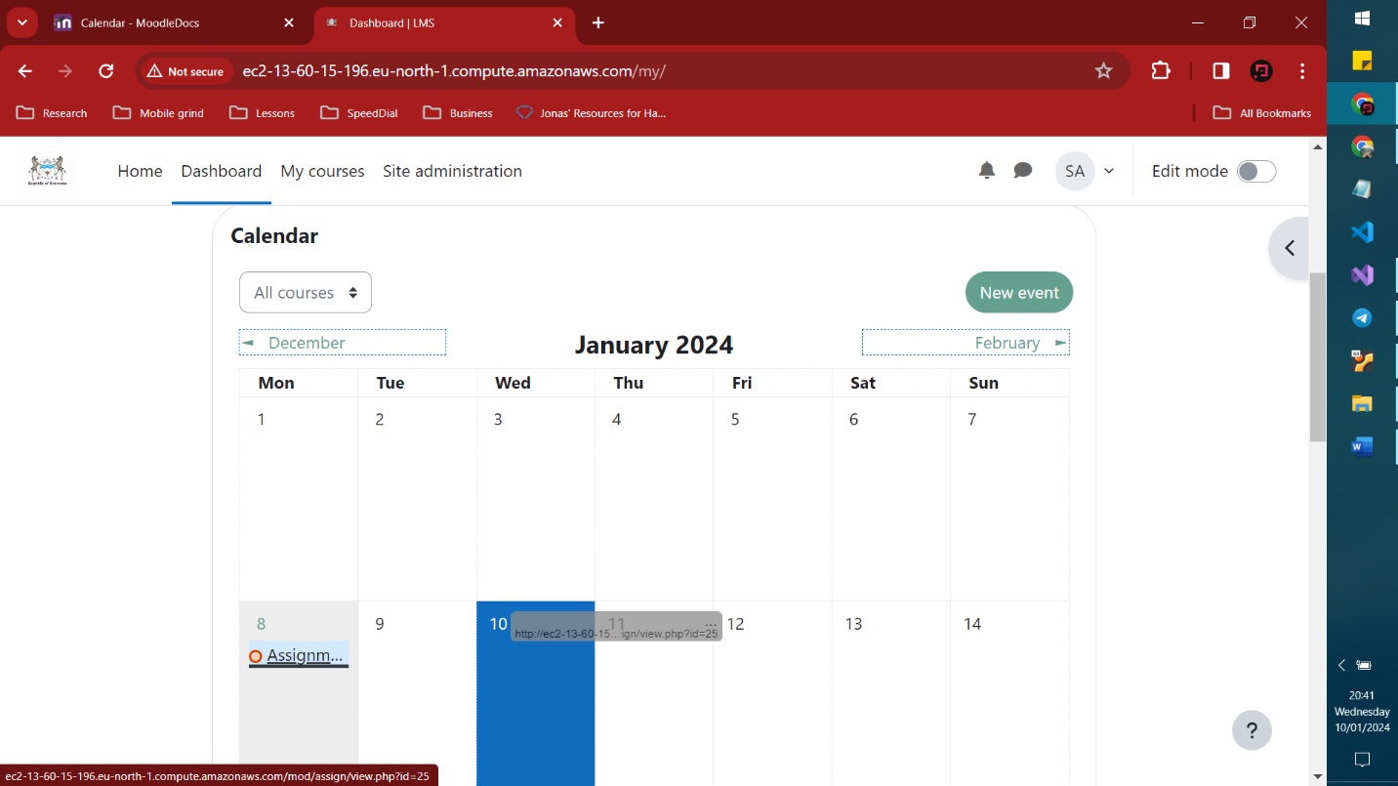

By clicking the Full calendar link at the bottom of the block you can then open the calendar page, wherein you can click the view selector at the top right and change period of events you are trying to view from day, month and upcoming.

